**Play Store Review Analysis**

**Team members  
Satyam Jyoti Sankar  
Krushnagopal Brahma**

**Abstract:**

Android is the dominant mobile operating system today more than 85% of all mobile devices running Google’s OS. The Google Play Store is the largest and most popular Android app store. We focus on analysing Google Play Store, the largest Android app store that provides a wide collection of data on features (ratings, reviews, type, ,install and number of downloads ,) and descriptions related to application functionality. The overall objective of this analysis effort is to provide in-depth insight about play store review analysis in general.

**1.Introduction**

The Google Play Store started life as the “Android Market” in 2008. It launched alongside the very first Android devices, and its purpose was to distribute apps and games.The Android Market was extremely basic at the beginning. It didn’t support paid apps and games until 2009. However, as the Android platform grew, so did the Android Market. By 2012, it featured over 450,000 Android apps and games.

By this time, Google’s ecosystem had expanded greatly compared to the humble beginnings of the Android Market. In fact, the Android Market was just one of the company’s online markets. At the time, this was the only place that Google had to sell goods. As the company’s hardware efforts grew, it was time for a new store. Posting reviews online has become an increasingly popular way for people to express opinions and sentiments towards the products bought or services received. Analyzing the large value of online reviews would produce useful actionable knowledge that could be of economic values to vendors and other interested parties.

Many apps are being developed as apps are easy to create and its lucrative. But its important for developers to know which apps are loved by customers and are trending in market so that he develop only those apps and also there is a high competition between app providers producing similar applications. Analysing customer needs is one of the bizarre tasks in the business world today. Hence proposing analyse data to developer that what customer is likely to download, which category got the maximum downloads this all plays a crucial role in app development. Generally, customers download apps depending on number of downloads, positive reviews, negative reviews, ratings and comments. So, in this project we are going to help the users by categorizing positive, negative and neutral reviews and comments of the particular. we are going to help developer by analyzing the desire of the customer through the reviews provided in the feedback section and apps trend in the market to help the organization & developers. Also provide an idea about app that managed to get maximum and minimum number of downloads and predicting the category of apps that is most likely to be downloaded in the coming years. The dataset of google Play Store for analyzing is collected from dataset.

The purpose of our project is to gather and analyze detailed information on apps in the Google Play Store in order to provide insights on app features and the current state of the Android app market.The Objective of the project to Explore and analyze the data to discover key factors responsible for app engagement and success.

**2.Problem Definition:**

The Play Store apps data has enormous potential to drive app-making businesses to success .Android is expanding as an operating system and Mobile app industry is increasing in significantly and thus giving rise to more competitions to the one’s that are creating applications .Due to the competition in the market and also expansion in order to help our developer understand what kinds of apps are likely to attract more users and what is the motivating factor for the people to download an app we analyze and research relevant data. For the app development in dustry where they can analyse the downloads and demand off app download in the industry.

The Problem statements are

1. What are the top categories on Play Store?
2. Are majority of the apps Paid or Free?
3. How importance is the rating of the application?
4. Which categories from the audience should the app be based on?
5. Which category has the most no. of installations?
6. How does the last update has an effect on the rating?
7. How does the count of apps varies by Genres?
8. How are ratings affected when the app is a paid one?

**3.EDA on given Data set**

There are two dataset:

1. **Play Store Data**(App, Category, Rating,Review,Size,Install,Type,current rating ,genres , Last update,Current Var ,Android Var)
2. **User Review Data**(App, Sentiment ,Sentiment Polarity, Sentiment Subjectivity)

By diagnosing the data frame, we know that:

* There are 13 columns of properties with 10841 rows of data.
* Column 'Reviews', 'Size', 'Installs' and 'Price' are in the type of 'object'
* Values of column 'Size' are strings representing size in 'M' as Megabytes, 'k' as kilobytes and also 'Varies with devices'.
* Values of column 'Installs' are strings representing install amount with symbols such as ',' and '+'.
* Values of column 'Price' are strings representing price with symbol '$'.

.

**4.****Rating distributaion (EDA)**

From this distribution plotting, it implies that most of the apps in the Play Store are having rating higher than 4 or in the range of 4 to 4.7.

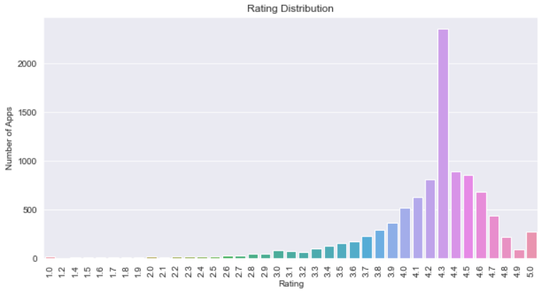

Fig 1: Pi chart of customer review .

## **5.Different type of app on base of price(free/paid).**

Here we see what is the percentage off free app and paid app in play store and from all app 92.2% app are free app and only7.8% app are paid app.

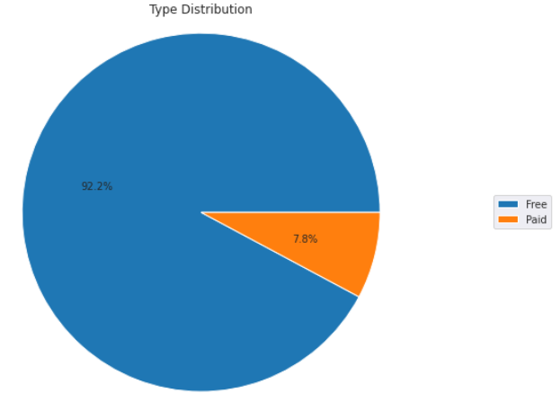

Fig 2: free vs paid app

**6.****Rating given by user from each category**

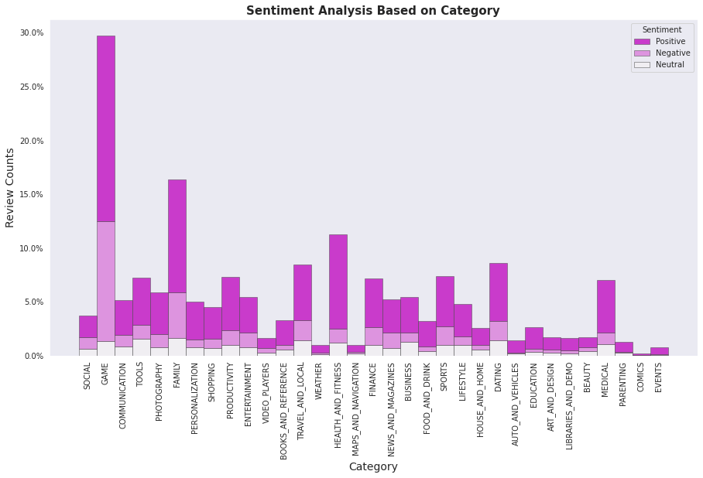Here we see that Performance of all app categories is mostly Decent. Highest quality apps with 50% apps with a rating higher than 4.5 are Health and Fitness and Book and Reference app. This is considered to be extremely high!However, the apps in Dating category having lower rating than the average ratings is 50%. 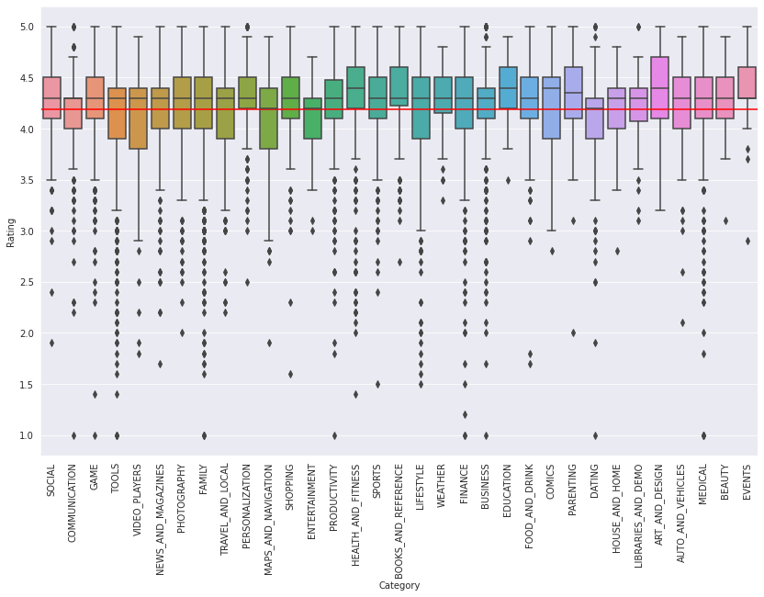

Fig 3: categories vs rating

## **7.Sentiment Analysis on different Category basis.**

Here we conduct the graph which show type sentiment analysis from each category.

This graph help us to know which category get highest sentiment review as well as compare of +ve and -ve review .

Fig 4: categories vs review count

Family, Sports and Health & Fitness apps perform the best, Having more than 50% positive reviews and Game and Social apps perform decent leading to 50% positive and 50% negative.

The number of review of game is much more higher in compare to other.

**8.Conclusion**

The Google Play Store Apps report provides some useful details regarding the trending of the apps in the play store. As per the graphs visualizations shown above, most of the trending apps (in terms of users' installs) are from the categories like GAME, COMMUNICATION, and TOOL even though the amount of available apps from these categories are twice as much lesser than the category FAMILY but still used most. The trending of these apps are most probably due to their nature of being able to entertain or assist the user. Besides, it also shows a good trend where we can see that developers from these categories are focusing on the quality instead of the quantity of the apps.

Other than that, the charts shown above actually implies that most of the apps having good ratings of above 4.0 are mostly confirmed to have high amount of reviews and user installs. The size and price shouldn't reflect that apps with high rating are mostly big in size and pricy as by looking at the graphs they are most probably are due to some minority. Furthermore, most of the apps that are having high amount of reviews are from the categories of SOCIAL, COMMUNICATION and GAME like Facebook, WhatsApp Messenger, Instagram, Messenger – Text and Video Chat for Free, Clash of Clans ,google apps etc.

Even though apps from the categories like GAME, SOCIAL, COMMUNICATION and TOOL of having the highest amount of installs, rating and reviews are reflecting the current trend of Android users, they are not even appearing as

category in the top 5 most expensive apps in the store . As a conclusion,

we learn that the current trend in the Android market are mostly from these categories which either assisting, communicating or entertaining apps.

### Some important point:-

* Average rating of (active) apps on Google Play Store is 4.17.
* If we see individually app wise the communication app like Facebook and whats-up get highly reviewed

app it shown that people regularly active on that and give there feedback also on that.

* Medical and Family apps are the most expensive and even extend upto 80$.
* Users tend to download a given app more if it has been reviewed by a large number of people.
* More than half users rate Family, Sports and Health & Fitness apps positively.
* Apps for games and social media get mixed reviews, with 50 percent positive and 50 percent negative responses.

**9.References**

1. Researchgate.net
2. https://www.academia.edu
3. GeeksForGeeks